Finding Articles Tutorial

Objectives:
We will explore:

- The role articles play in research
- Key features of newspapers, magazines, and journals
- How library databases can help
- How to find articles in library databases

The Role of Articles

Why Use Articles?
Does this sound familiar?

Your professor has assigned a research paper that requires you to find a number of articles from newspapers, magazines, or academic journals.

What’s up with articles?
Where can I find these articles?

How Articles Can Help
Up-to-Date
Magazines, newspapers, and journals are published more frequently than books so they tend to have the most up-to-date information.

It might take 2-3 years for a book to be proposed, written, edited, revised, copy-edited, and then professionally bound.

Most articles have a much faster turnaround time. Newspaper articles, for example, are often written, edited, and published the same day as a major event.

Short
This may seem obvious, but since articles are much shorter than books, they can help you consider a variety of perspectives, reports, or studies related to your topic much more quickly and easily.

When you consider multiple perspectives and publications, you strengthen your own credibility as a student writer.

Specific
Articles tend to cover a very specific aspect of a topic, while books often cover a subject more broadly.

For example if you’re researching plastic bottle recycling initiatives in Austin, TX, you might find general material about plastic bottles and urban recycling in a book about recycling.

But the local facts and specific details related to projects in Austin are more likely to come from articles in local news sources like the Austin American-Statesman and the Austin Chronicle.

Scholarship & Research
Has your professor asked you to find scholarly or academic journal articles?

Academic journals contain the latest research and experimental study results. Academic articles are written by scholars in a particular field.

Top academic journal articles are reviewed by a panel of experts before publication in a process called peer review, so they are among the most trustworthy or credible sources you can find on a given topic.

Types of Publications

Newspapers, magazines, and journals are the three most common source types you will encounter when searching for articles.
Each source type offers different kinds of information and has unique strengths, so it’s important to understand their key features and differences. Then you’ll have a better idea of which source might help in any given situation.

Magazine vs. Journals – how they differ-
- Audience
Magazines:
- General public
Journals:
- Professionals in a field
- Scholars
- Experts

- Authors
Magazines:
- Journalists
Journals:
- Professionals in a field
- Scholars
- Experts

- Content
Magazines:
- News
- Non-technical articles
- General interest articles
- Glossy Photos and ads
- No bibliographies

Journals:
- In-depth research
- Technical language and jargon
- Original research studies
- Charts and graphs
- Bibliographies

- Time Frame
Magazines:
- May be published Weekly
- May be published Monthly
Journals:
- Quarterly (4 issues/year)
- Biannually (2 issues/year)
- Some monthly (12 issues/year)

- Why Use Them?
Magazines:
- Broad overview
- Popular perspective
Journals:
- Current research
- Data and statistics

Here is another place you can find articles: Newspapers
What about newspapers?
Newspapers are written by reporters and journalists for the general public. They focus on local, national, and international events and issues as they unfold.

They also include opinions, editorials, lifestyle features, and entertainment reviews. They are published daily.

Newspapers are best when you want to know:
- what is happening right now
- what was happening at some point in the past

Try This!
Matching Exercise: What is it?
Match each clipping description to the correct source type, enter the number for the source in the blank. (Match clippings to source types.)

Source types:
- Magazines
- Newspapers
- Journals

Clipping descriptions- put a 1 for Magazines, 2 for Newspapers, or 3 for Journals to identify the source type listed above that matches the descriptions A-N below:
___ A. Glossy look, many photos
___ B. Written by reporters
___ C. A full-color feature on “what not to wear”
___ D. First reports of a plane crash
___ E. Original research & experiment results
___ F. Written by scholars and researchers
___ G. Published daily
___ H. Reports of analysis of last night’s election
___ I. A 5-page spread on “best summer beach reads”
___ J. Peer-reviewed by experts
___ K. Coverage of a local political scandal
___ L. Formal language, lots of jargon
___ M. Includes a bibliography of sources consulted
___ N. Published quarterly

How Library Databases Can Help
Articles in the Library

Student: “OK, I get it. Articles are awesome. But how do we find them?”

- Inside the Library: Libraries often have small collections of print magazines.

- On the Library Website: You can find far more articles online in Library Databases.

Library Databases
Databases: Databases are huge containers of high-quality sources. They contain credible, professionally published articles.

In fact… we might even think of searching databases as shopping in a store.

Types of Databases
Imagine you need light bulbs!
You have choices. You can go to…
- Warehouse Stores
- Specialty Shops

- General Databases
These are like Warehouse Stores-
Pull in, grab a flatbed, and roll through the warehouse. You’ll find a little of everything. Pretty convenient, huh?

One-Stop Shopping
Some library databases are like Costco, Sam’s Club, or Wal-Mart.

The quick search box on the Library Home Page gives you the warehouse experience.

Search the Library
The search box on the Library Home Page taps almost all of the library’s general and subject-specific databases. Make sure you select the “Journals, magazines, news” tab to display these article results.

You can also display “Books, movies, music” results from the library collection, so just be aware of which tab you’ve selected.

- Subject-Specific Databases
These are like Specialty Shops
If you need light bulbs—especially of unique shapes and sizes—you might head to The Light Bulb Shop.

Other databases are like specialty shops.
Try searching a subject-specific database. For example, if you know you need nursing articles, you might head straight to a Health & Medicine database.

Try browsing “Databases by Subject” on our A-Z List of Databases page.

Examples of Subject-Specific Databases
If you need the best available material for a certain class, you might try searching a subject-specific database.

Browse the subject categories on our A-Z list and you’ll find databases for Art, English, Health Sciences, History, Nursing, Philosophy and many other major subjects at ACC.

Here are some examples:
- American History Online
- Medline Plus
- Bloom’s Literature

A question many students may ask:
Can I Use Online Articles?
“My professor says no online sources!”

Are You Sure That’s What He/She Meant?
The full-text articles you find in library databases aren’t just random web pages and blog posts floating along the surface of the open web like pond scum.

Here’s the Deal…
They’re identical to those that have been published and bound in print.

Case Study: Popular Psychology
In Print: You can go to the library and find a print copy of an article in the magazine, Popular Psychology.

Full-Text online: You can find a full-text PDF of the very same Popular Psychology article in the library database, Academic Search Complete.

The PDF is available 24/7! You can print it, email it, or save it to your laptop or thumb drive to read later on.

And you can tell your professor, it’s not a web page; it’s simply a PDF, which is a scanned copy of an article that originally appeared in print.

Finding Articles in Databases
Searching Databases

Demo:

Let’s look at how to search for articles in the general database, Academic Search Complete.

Let’s search one of our best multi-subject databases: Academic Search Complete.

Most article databases have similar features. Once you learn the basics, you’ll be able to apply these lessons to other databases.

- Click the “A-Z List of All Databases” Link

Figure 1 screenshot of library home page
Choose A-Z List of Databases

You can use the A-Z List to jump to any online database by name. Or you can browse a list of databases by Subject.

- Click the “A” Link

- Click the “Academic Search Complete” link

Off-Campus Access
If you’re off-campus, you’ll be prompted to enter your
ACC eID and Password after clicking the link.

Welcome to Academic Search Complete!

If you would like to try a keyword search…

Database search bars don’t work quite the same way as Google’s search bar. You’ll need to break your topic into a few keywords.

Example:
Let’s search for articles about how sleep affects college students.

Tips:
Use quotation marks around phrases like “college students” to get better results.
Use the word “and” to combine keywords.

- Type: “college students” and sleep
- Then hit Enter
- Click the Search key

Figure 5: Screenshot of Example search results- "college students" and sleep
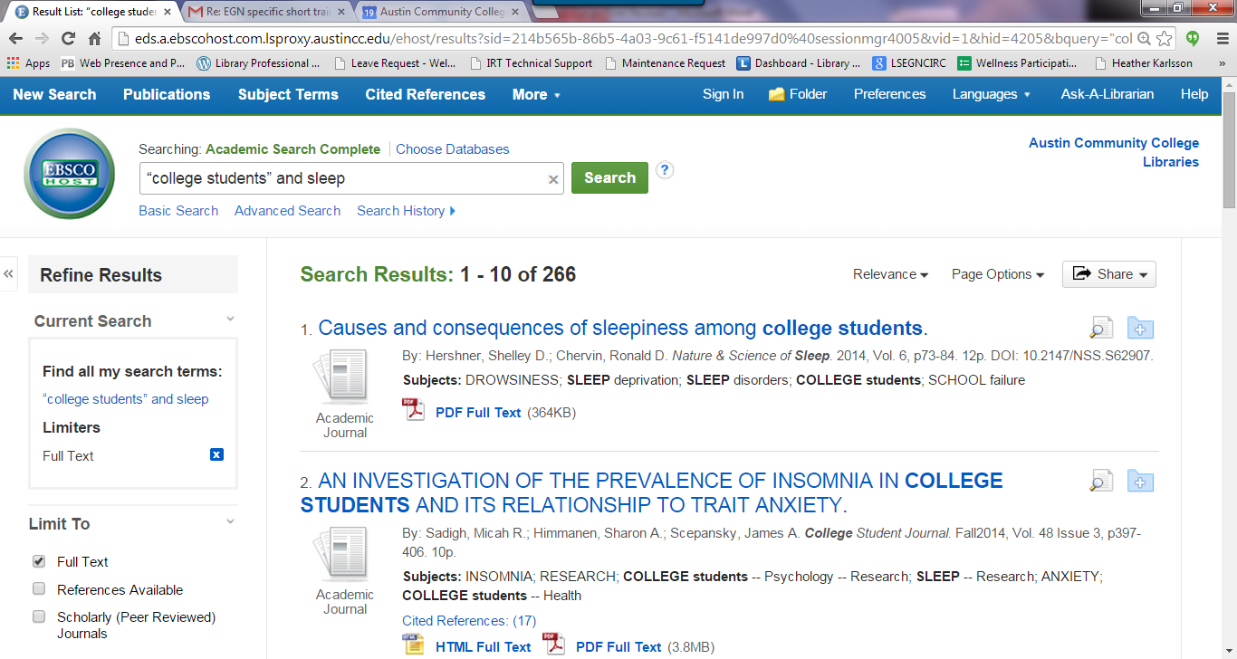

Most databases list search results in the center.
Options for filtering your search results usually appear on the left.

Source Types: Notice that you can narrow your results to a single source type such as academic journals, newspapers, or magazines.

- Click the “Magazine” check box

Magazines Only

Now the database displays only the 53 magazine results. Sometimes it’s helpful to view one type of article at a time. Try looking at Academic Journals and Newspapers, too.

You can learn more about an article by clicking the title link.

- Click the title for Result #5: “More Slumber Time Means Better Performance in Class” link.

Article details show information about each article.

Now we can see:
- Complete source information
- A list of subject terms (blue links)
- And a brief summary or “Abstract”

All databases will let you Print, Email, or Cite your article- these options appear in the column in the right of the detailed record under Tools.

Choose Cite from the Tools menu to create an MLA citation for your bibliography.

Most databases have some sort of Citation Tool.

This tool requires you to locate the MLA Style by scrolling through a list of citation styles. Here is the MLA Style citation for your article #5:

Just highlight the citation, then Copy and Paste it into your bibliography.

Note: This example shows an MLA 7th Edition citation. Not all citation tools generate MLA 8th edition citations yet, so you may need to make corrections

Where’s the Article?
To read or download a copy of the article, just look for the “Full Text” link.

Click the “PDF Full Text” link.

Here’s your article!

You can read the article in your browser, SAVE the PDF to read later, or PRINT a hard copy.

Another way to narrow your results is to browse one of the lists of Subject Terms. These are listed as blue links in the detailed record.

You can also find Subject terms back on the Search Results List screen that listed all 53 results. It is listed under Refine Results in the left column. Scroll down to find Subject Terms.

You may find a subject that really captures the concept you’re looking for. If you select one of these subject terms, like “insomnia.” it will narrow your results.

Now you will see only articles that list “insomnia” as a subject term in your results, and you will have less articles to look at – only 6 instead of 53!

More information about Databases in general:
Most databases have similar tools and features to help you refine and manage your results.

- Articles usually have Abstracts, which are brief summaries of the article. Read the abstract first to see if the article discusses the topic you are researching.
- When you search in a database, there is usually a way to narrow or refine your results by subject, date, peer-reviewed/academic/scholarly journals or even by geographic area. For example, if you search for information about property taxes, you can narrow your search by choosing Geographic area: United States.
- You can sort your search results list by Relevance or Date. For example, if you want to see the latest articles, sort by Date- Newest.
- If you want to read the entire article, choose the link that says PDF Full Text, HTML Full Text or Full Text (depending on how the database labels this feature).
- Look for Tools or Cite or Citation to learn how to cite the articles you find in MLA style or any other style assigned by your professor.

Recap
In this tutorial you have learned:
- The role articles play in research
- Key features of newspapers, magazines, and journals
- How library databases can help
- How to find articles in library databases

Now let’s test your understanding of these concepts.

Quiz
The following quiz consists of 5 multiple choice questions. Each question is worth 10 points. Put the letter for the correct answer in the blank provided below.

_____ 1. Which statement about articles is false?
- Articles are published more frequently than books
- Articles tend to cover a broader subject
- Newspaper articles have the most up-to-date information
- Academic articles are peer-reviewed

_____ 2. If you were looking for clinical research on obese children, which would be the best resource to use?
- Journals
- Newspapers
- Magazines
- None of the above

_____ 3. Which of the following statements about the Quick Search tool on the Library Home Page is False?
- You’ll find resources in the library’s General and Subject-Specific databases
- You can find newspapers, magazines, and academic journals with Quick Search
- Results from the Quick Search will not include books, e-books, or DVDs
- You can search the Library Catalog and Library Databases with Quick Search

_____ 4. What similar tools and features are available in most databases? Select all that apply.
- Citation/Abstract
- Publication title
- Sort results by
- Source/Document type

_____ 5. Which is not true about newspapers?
- Written for the general public
- Includes editorials and opinions
- Includes articles written by scholars and researchers
- Includes information about what is happening right now

If you are required to turn in this quiz to your professor, please print by selecting FILE => PRINT. If you are required to email the quiz to your professor or upload it to Blackboard, please choose FILE => SAVE.

Get Help
If you need help with the material introduced in this module, ACC Librarians would be happy to assist you. Visit the Ask a Librarian page at http://library.austincc.edu/help/ask.php to see how you can reach us in person, by phone or email, or via Live Chat.

Answer Key:

Matching Exercise:
1 – A
2 – B
1 – C
2 – D
3 – E
3 – F
2 – G
2 – H
1 – I
3 – J
2 – K
3 – L
3 – M
3 – N

Quiz:
1 – B
2 – A
3 – C
4 – A, B, C, D
5 - C

